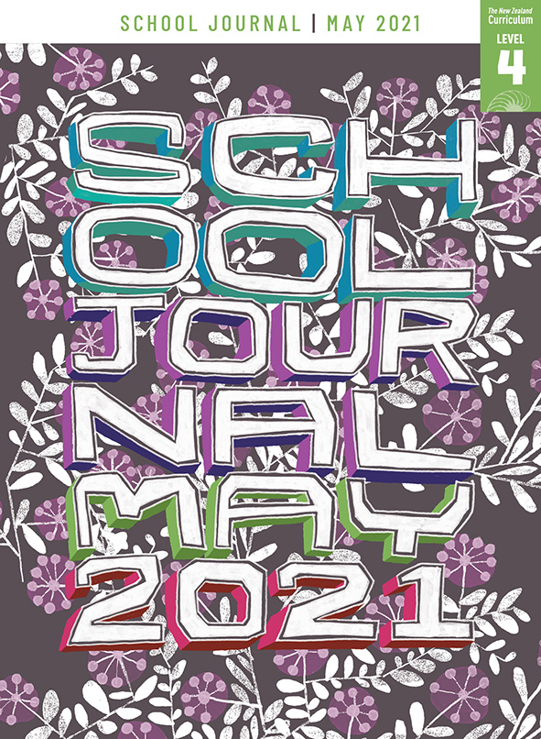

Break-up Day
by Kyle Mewburn
School Journal
Level 4, May 2021
Year 8

The Learning Progression Frameworks (LPFs) describe significant signposts in reading and writing as students develop and apply their literacy knowledge and skills with increasing expertise from school entry to the end of year 10.

Overview
Kyle Mewburn shares her experience of growing up as a transgender girl and explores gender in a way that shows how, despite the challenges and expectations of others, she managed to find a sense of identity and belonging.
A PDF of the text is available at www.schooljournal.tki.org.nz

Before using this text
This text has strong links to relationships and sexuality education, one of the seven key areas of learning in health and physical education:
Learning in the area of relationships and sexuality education (RSE) aims to enable young people to understand themselves and to develop the knowledge, skills, and attitudes to think about and engage in positive and healthy relationships. It includes:
- learning about the self (physically, socially, emotionally, and spiritually)
- gaining knowledge and skills for meaningful and supportive relationships with others
- learning about social, political, cultural, and environmental contexts, and taking action within these contexts.
RSE covers learning about relationships as well as about gender and about sex and sexualities. It considers social and emotional learning and looks at how young people can come to understand the physical and social contexts of gender, bodies, and sexuality. This enables ākonga (students) to enhance their interpersonal relationships, now and in the future. The formation of young people’s sexual and gender identities is viewed as an ongoing lifelong process.
Relationships and Sexuality Education (Years 1–8), Ministry of Education, 2020, Page 10
Before using this text with your students, it is important to consider your school’s relationships and sexuality education (RSE) programme. Schools must consult with their communities on the delivery of this learning, meaning it will be different in every school.
Note that parents and caregivers have the right to withdraw their child from all or part of an RSE programme. Are there any students in your class who have been withdrawn from RSE in total or in part? Clarify on a case-by-case basis, depending on the nature of the request to withdraw, whether using this article would be considered unsuitable for these children and their parents or caregivers.
Be aware that the story could raise issues and sensitivities for some of your students as well as elicit questions about sexuality, sex, and gender. Approach the text in an inclusive way that supports all your students and ensures their safety and wellbeing. See “Helpful resources” below for further information and ideas to help you do this.

Themes
- Gender identity | - Belonging | - Wellbeing

Related texts
“Nobody Laughed” SJ L2 Sept 2014 | “Alvin and Me” SJ L3 May 2017 | The Phantom Tollbooth by Norton Juster
The Hoppleplop by Kyle Mewburn

Helpful resources
Relationships and Sexuality Education – A guide for teachers, leaders, and boards of trustees: Years 1–8 (PDF)
Relationships and Sexuality Education – A guide for teachers, leaders, and boards of trustees: Years 9–13 (PDF)
Note: These guidelines were refreshed and distributed to all schools in 2020.
Sexuality education for curriculum levels 1–4: This website includes a range of materials for teachers and students designed to support schools to develop and implement their relationships and sexuality education programmes.
Inclusive Education: This website gives information and support to help schools and teachers create an inclusive environment for all students, including LGBTQIA+ students.
InsideOUT: This national organisation works with youth, whānau, schools, community groups, youth services, government agencies, and other relevant organisations to provide safer schools and communities for rainbow (LGBTQIA+) young people. The website includes a wide range of information and resources for teachers and students.
Out on the Shelves: This online resource lists books with rainbow themes and characters, with the aim of supporting rainbow young people to find stories that represent their identities in positive and affirming ways.
Rainbow Youth: This youth-led charitable organisation works with queer, gender diverse, takatāpui, and intersex youth and their friends, whānau, and wider communities to ensure that Aotearoa is a place where all young people can thrive. This website provides information, resources, and links to support services.
K. Fitzpatrick, K. Wells, G. Tasker, M. Webber, and R. Riedel. Mental health education and hauora: Teaching interpersonal skills, resilience, and wellbeing. NZCER Press. This PDF, aimed at teachers of years 7–11, has supportive background information on gender identity and terminology (see lessons 4 and 5).

Strengthening reading behaviours (what to notice)
Text structure and features | Requiring students to:
- Implied information  No wonder nobody realised I was a girl – I was in the wrong body. A girl in a boy-shaped box. Somebody had obviously made a terrible mistake. Yet there was absolutely nothing I could do about it. | - synthesise the information from the photos with Kyle’s descriptions of events and her feelings and reactions to understand that she has always identified as a girl or woman
- Abstract ideas  As always, I blamed myself. No wonder he didn’t want to be my friend. I was a complete fraud – a fake boy.  Adapting my behaviour and, more importantly, my emotional responses was essential if I wished to avoid punishment, ridicule, or worse. | - integrate descriptions of how Kyle felt when she was separated from Keith with how she needed to behave, think, and feel like other boys so they can understand the emotional complexity of Kyle’s response to her situation
- Flashback  Although the title suggests that the story is about the last day of school, it begins with Kyle recalling the first day of term, when she and Keith are first put into separate classes. | - notice the sentences “But the year hadn’t unfolded as I expected – and Keith was no longer my friend” and infer that they signal a shifting of focus
- Commentary by the author  There was no big drama or anything.  That was just the way things were. | - use the clues provided to understand that the information about Keith adds more detail and insight into Kyle’s own personal identity.

Vocabulary
Possibly challenging words and phrases | suburban sprawl, assigned, bewildered, abandoned, fraud, fawned over, regimes, ridicule, writhing, grappled, supremacy, opponent, intervened, lurking, era, non-binary, defective, flying under the radar, voracious, brainiac, yearned, nostalgic, wave of embarrassment, realm, compelled

Helpful prior knowledge (pre-reading and introducing the text)
- The genders that people are assigned to aren’t always correct or true to who they are.
- Kyle says that she has always identified as a girl or woman. Other transgender people may not work this out until later in life, but that doesn’t make it any less true for them than for someone who has known from an early age.
- The expectations of others can impact personal growth and happiness.
- Coming to terms with who you are and being able to express this fully can take many years.

Possible reading and writing purposes
- Identify and analyse the author’s purpose in writing this memoir
- Analyse and discuss how expectations from family and society can have an impact on identity and happiness
- Explore and discuss the impact on Kyle of her teacher’s actions
- Analyse and evaluate the text structure and features Kyle uses in her memoir.
See Effective Literacy Practice in Years 5–8 for information about teaching comprehension strategies (Teaching comprehension)
and for suggestions on using this text with your students (Approaches to teaching reading).

Possible curriculum contexts
This text has links to level 4 of The New Zealand Curriculum in:
ENGLISH HEALTH AND PHYSICAL EDUCATION RELATIONSHIPS AND SEXUALITY EDUCATION

Understanding progress
The following aspects of progress are taken from the Learning Progression Frameworks and relate to the specific learning tasks below. See the LPFs for more about how students develop expertise and make progress in these aspects:
- Acquiring and using information and ideas in informational texts
- Making sense of text: reading critically
- Creating texts for literary purposes
- Creating texts to influence others.

Strengthening understanding through reading and writing
Select from the following suggestions and adapt them according to your students’ strengths, needs, and experiences.
Note: Most of these activities lend themselves to students working in pairs or small groups.
- Have the students read the memoir independently. As they read, ask them to note unfamiliar words, connections they make to the text, and anything they found interesting and would like to share with others. Remind them to record page numbers as well so that they can locate the place again easily.
- After reading, ask the students to discuss or record a Who, Where, When, What background check. Confirm that they have noticed the flashback and clarify that Kyle is writing about a time about forty years ago in Brisbane, Australia. Ask them to identify the clues that tell the reader what things might have been like then.
- Ask the students to discuss how society and other people can influence how we think, feel, and act. Have them scan back through the text looking for events that may have been a significant influence for Kyle. Record these or highlight them on a photocopied text so you can discuss them further. For each one, ask the students: How might this have made Kyle feel? At the time, what did she do about it? How did this influence what happened next? Were there other choices Kyle could have made? Were there influences beyond her control? What were these?
- Explain the difference between a memoir, a story, and an autobiography. Prompt the students to consider why Kyle Mewburn wrote this memoir. Why might the author have decided to share this part of her life? What connections can you make with her experiences? Reading Kyle’s memoir, you get to see life from someone else’s perspective. How does this make you think differently about what others might be thinking or feeling?
- To help the students identify and analyse the author’s purpose, ask them to find significant incidents that had importance for Kyle and record these in the left-hand column of the Author’s purpose graphic organiser on page 4 of this TSM. In the middle column, have them write the words and phrases that show how Kyle felt about those incidents (for example, “meaningless label”, “fly under the radar”, “Shame was my constant companion”, “voracious secret reader”, “As always, I blamed myself”, “I was a complete fraud – a fake boy”, “lived under different regimes”, “iron rules that governed every action, every emotion”, “Adapting my behaviour and, more importantly, my emotional responses was essential”). Then, in the right-hand column, they write why the author chose these words and phrases and what they reveal about Kyle.
- Reread the introduction: “On my last day of primary school, two unusual things happened. One would prove life changing, in a roundabout kind of way. The other was more of a non-event, really. Yet if you’d asked me at the time which was which, I’d almost certainly have gotten it wrong.” If necessary, support the students to identify what those two things were. Ask them to explain why the sponge was so significant to Kyle at the time and why the teacher giving her the book proved more significant in the long run.
- Have the students create a flow chart to represent the pathways of these two things and demonstrate how one proved to be a non-event and the other proved to be life changing. They could write a summary statement explaining the meaning of the final sentence, “Yet if you’d asked at the time which was which, I’d almost certainly have gotten it wrong.”
- A memoir is about a moment in time, an event, or a memory about something. Ask the students to write their own memoir using “Break-up Day” as a model. Remind them to combine their account of what happened with a description of their thoughts and feelings at the time and their view of the event now. Topics might include moving school, moving house, a family holiday, a special event, a loss, or starting the school year.

“Break-up Day” Author’s purpose

Incident | What Kyle is thinking  (words from the text) | Why the author chose these words  and what they reveal about Kyle
Keith was assigned to a different class. | In disbelief, felt bewildered. Abandoned. Alone. | Strong words – they show how much the separation from Keith meant to Kyle.
Keith sitting with new friends. No place for Kyle to sit. | As always, I blamed myself. I was a complete fraud – a fake boy. | Kyle has very low self-esteem. She thinks there is something wrong with herself.

How does the story help us think about belonging, wellbeing, and gender identity?

What is the author’s main message?

Do you think Kyle Mewburn achieved her purpose in writing this story? Why?

